* Why must we do it?
  + Why is the championship important?
    - What happens if the championship is not organized?
      * If it is not organized without good reason, it will negatively impact the relations between the Dutch and the other European associations. It will probably also impact the relationship between them and their sponsors, which will probably result in fewer sponsors. If something goes wrong at the championship itself the Dutch association will be responsible and if something goes wrong financially the board members and commissioners will be (partly) liable.
    - What happens if the championship goes well?
      * The association will probably get more members and sponsors and it will probably also tighten the relationship between the association and the other European associations. It will also prove the success of the organization and such kinds of events will be held again.
  + Why should **we** organize it?

We should organize it because we are the chairman of the Dutch Lusitano association. As chairmen we want to stimulate the use of Lusitano horse around the movie and raise awareness of the significance of the breed.

The championship is organized every 2 years and this time it’s our time to organize it.

* What is it exactly what we are going to do?
  + What does the championship look like?
    - At the championship in each category (breed classes, Dressage and Working Equitation) an individual European Champion will be determined.
  + How long will the championship last?
    - The European Dressage championship took place from 22 to 26 July in Germany, 2020. The event we are going to organize is going to start from 22nd of July (Friday) and it will last from 5 days up to a week.
  + How many people will come?
    - Couldn't find relevant data. The only thing found was that in one of the events the participants were around 400.
  + How many people will compete? / Who will compete?
    - "I was totally amazed by the large crowds and tons of horses at the European Lusitano Championships," she said. "Hundreds of horses competed there in breed classes, working equitation as well as dressage. The owners and breeders are so incredibly dedicated to the Lusitano horse, and they were very interested to find out more about Sal."
* Who is going to what?
  + Who are the stakeholders? / Who will sponsor the event?
  + 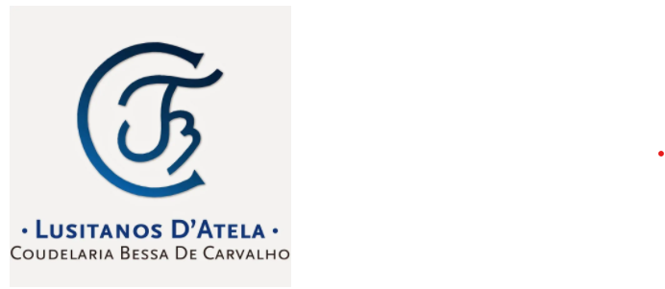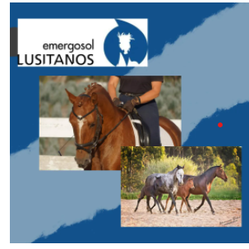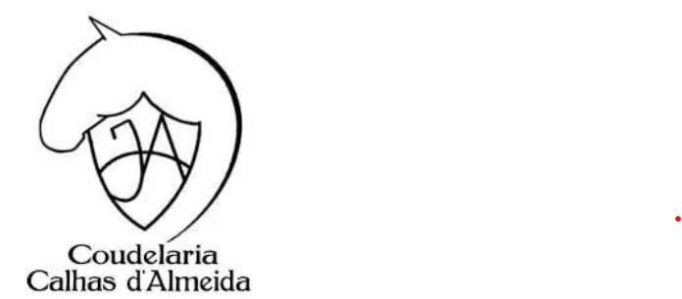
  + Who will be responsible for what?
    - As a director of an association, you are in principle not liable for debts incurred in the name of the association. This legal form enjoys full legal jurisdiction. This means that the association may enter into obligations as a legal person. The board is then not liable, but the company.

in order to obtain this full legal jurisdiction, it is necessary that you set up the foundation by means of a notarial deed. We are not sure if our association is set up with a notarial deed

Despite the protection provided by full legal jurisdiction, the board of an association can still be held liable in very exceptional cases.

A board of an association can be held liable for the debts incurred in the event of improper management.

This is laid down in an Article of the Dutch Civil Code. What exactly constitutes mismanagement is not precisely defined in this article.

The practical interpretation of improper management differs from situation to situation. This is usually filled in by case law, current developments and literature on this subject

Another tip to protect yourself as director: Take out insurance to protect your private assets.

* When are we going to do it?
  + What is the schedule for organizing?
    - The championship will take place on Friday, 22nd of July. On Saturday (23rd), the welcome of the nations will be scheduled at 19:00pm. There will be a parade with the national flags, the welcoming of the athletes and an informal evening.
  + What is the schedule for the day of the championship?

The championship will start with an opening where the full schedule for the day will be explained.

The activities will be separated into a timetable that for all participants to review.

* + Where will it be held?

Venue is to be decided. As soon as we have more information about the approximate number of people that will be visiting, we will propose a potential venue for the event to be held

* How are we going to do it (means, resources, finances)?
  + What resources do we need?
  + How much money does the association have to spend?
    - Every year the championship cost has been going up. The first time it was organized it was in France. The financial details are unknown for that year. The second championship in Belgium was about 35k. The third was in Germany and cost 72k. The fourth in Switzerland was cancelled, however they were working with a 100k budget. Therefor we expect the championship to cost at least a 100k, but probably a bit more than that
  + Do we need sponsors and if so, how much money would we need?
  + How will we reach our target audience? (How will we advertise it? )/ How will we promote ourselves?
    - We will use the social media accounts of the Dutch association and ask the other European associations to also post it on their accounts. We will also put it on our website.